MyPass Password Manager - Project Report
By: Mouhannad Chehab and Mohammad Shehab
Course: CIS 476

1. Project Overview
MyPass is a desktop password manager built with C# WinForms that securely stores passwords, credit cards, identity info, and notes using AES-256 encryption.
Technologies:
- C# .NET 8.0 WinForms
- SQLite + Entity Framework Core
- BCrypt password hashing
- AES-256 encryption
2. Design Patterns
2.1 Singleton Pattern - User Session
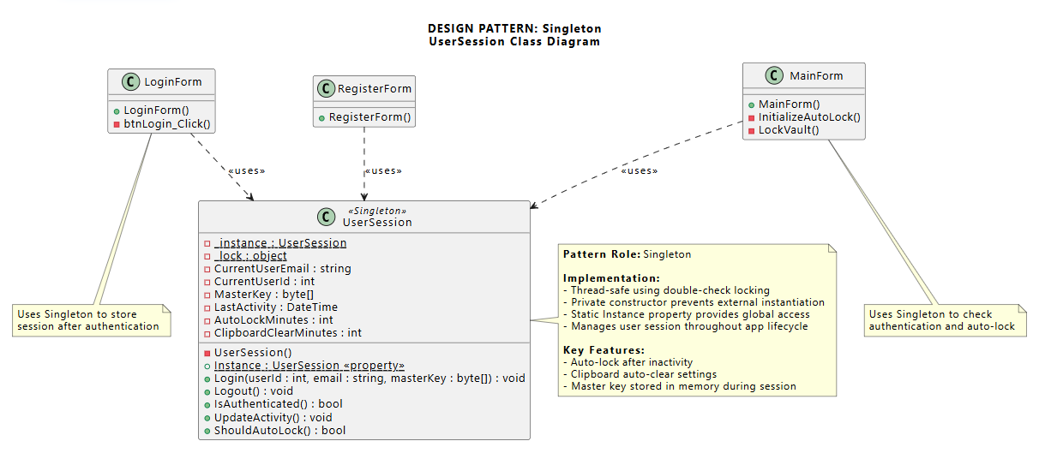
Purpose: One user session throughout the app.
Mapping:
- UserSession → Singleton
- Instance property → getInstance()
Implementation: Thread-safe, manages login state and master key.

2.2 Observer Pattern - Notifications
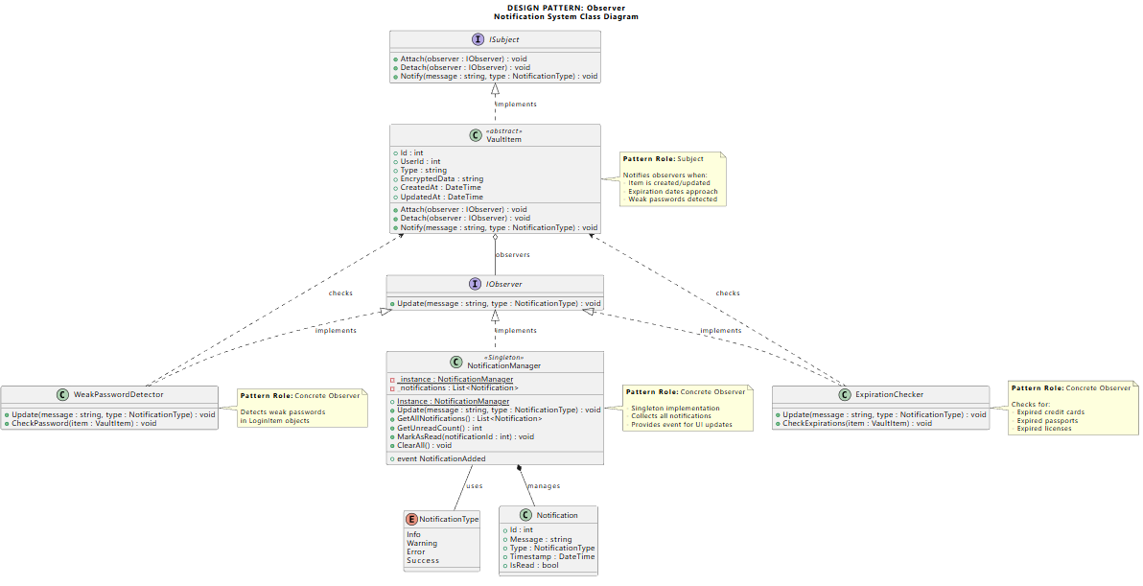
Purpose: Notify users about weak passwords and expirations.
Mapping:
- IObserver → Observer
- ISubject → Subject
- VaultItem → ConcreteSubject
- NotificationManager, ExpirationChecker, WeakPasswordDetector → ConcreteObserver
Implementation: VaultItem notifies observers when items change. Observers check for weak passwords, expired cards, passports, and licenses.

2.3 Mediator Pattern - UI Coordination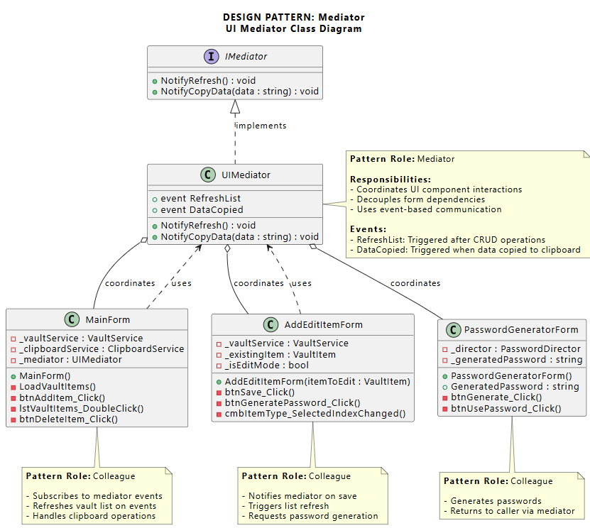
Purpose: Coordinate form interactions without direct coupling.
Mapping:
- UIMediator → ConcreteMediator
- MainForm, AddEditItemForm, PasswordGeneratorForm → Colleagues
Implementation: Forms communicate through mediator events instead of calling each other directly.

2.4 Builder Pattern - Password Generator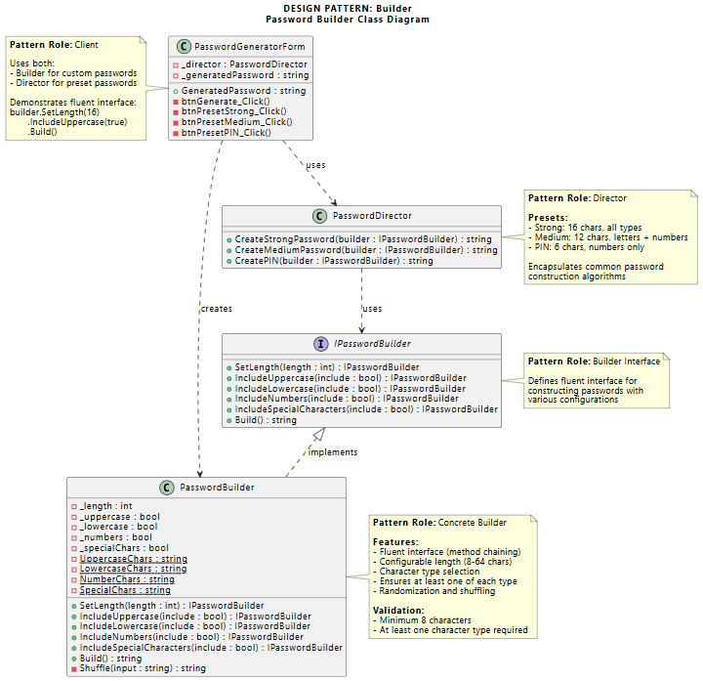Purpose: Build passwords with configurable options.
Mapping:
- IPasswordBuilder → Builder
- PasswordBuilder → ConcreteBuilder
- PasswordDirector → Director
Implementation: Fluent interface for password generation. Director provides presets (Strong, Medium, PIN).
csharp
password = builder.SetLength(16)
.IncludeUppercase(true)
.IncludeLowercase(true)
.Build();

2.5 Proxy Pattern - Data Masking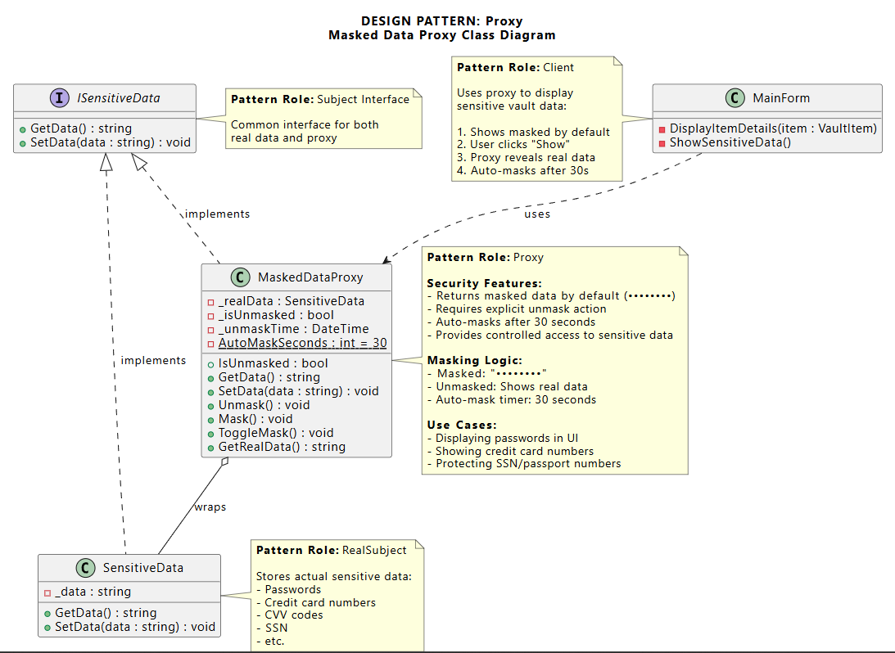
Purpose: Hide sensitive data by default.
Mapping:
- ISensitiveData → Subject
- SensitiveData → RealSubject
- MaskedDataProxy → Proxy
Implementation: Shows "••••••••" by default. User clicks to unmask. Auto-masks after 30 seconds.

2.6 Chain of Responsibility - Password Recovery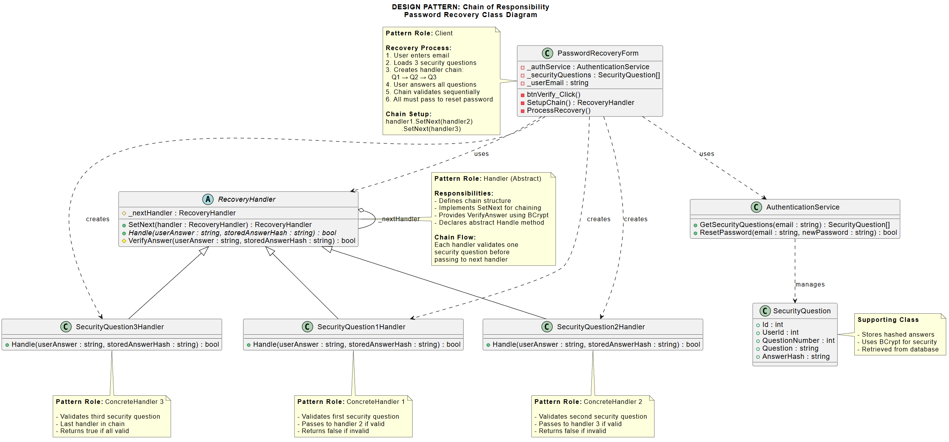
Purpose: Validate three security questions sequentially.
Mapping:
- RecoveryHandler → Handler
- SecurityQuestion1Handler, SecurityQuestion2Handler, SecurityQuestion3Handler → ConcreteHandlers
Implementation: Chain of three handlers. Each validates one question. All must pass to reset password.

3. Database Schema
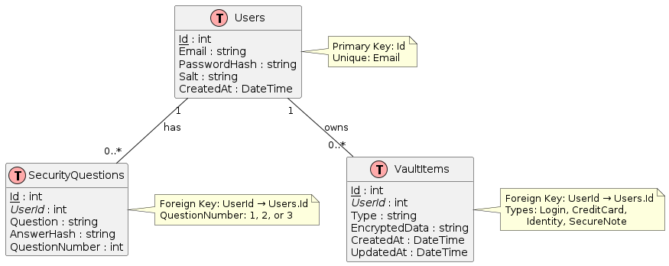
Tables:
- Users: Id, Email, PasswordHash, Salt
- SecurityQuestions: Id, UserId, Question, AnswerHash, QuestionNumber
- VaultItems: Id, UserId, Type, EncryptedData, CreatedAt, UpdatedAt
Security:
- Passwords hashed with BCrypt
- Vault data encrypted with AES-256
- Master key derived with PBKDF2

4. User Interface
Login
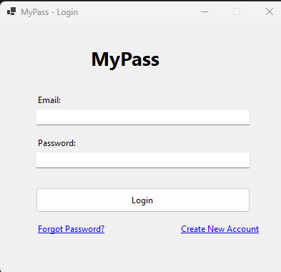
Register
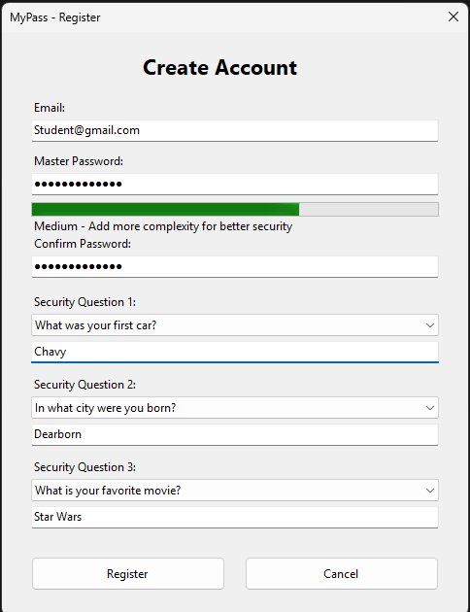
Main Vault
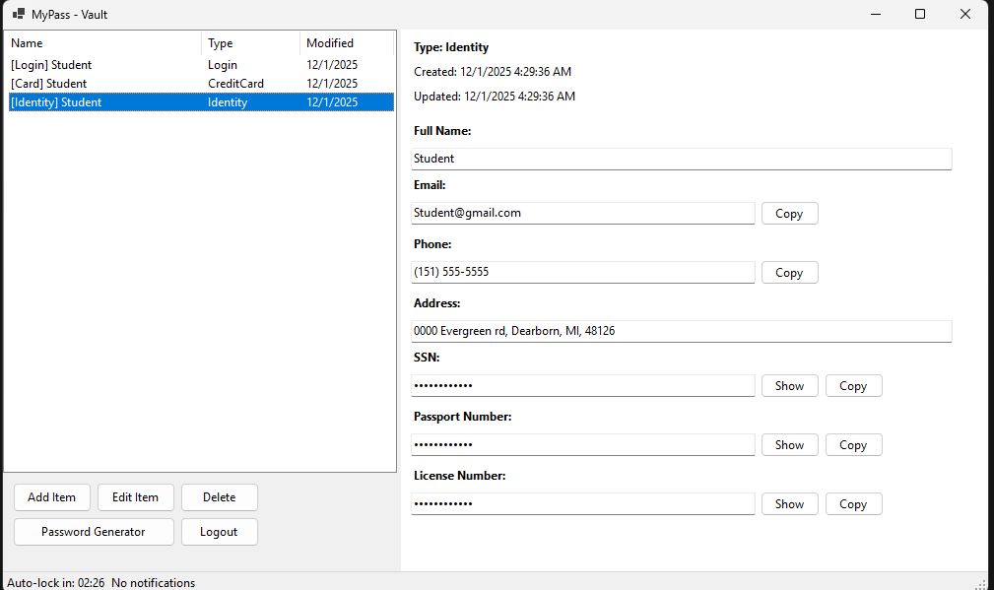
Add/Edit Item
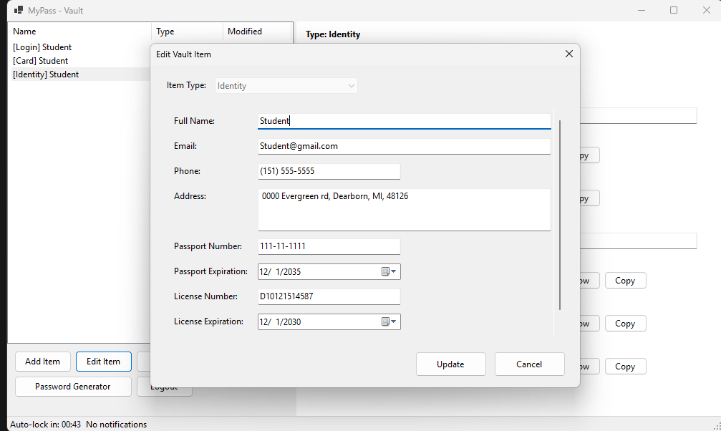
Password Generator
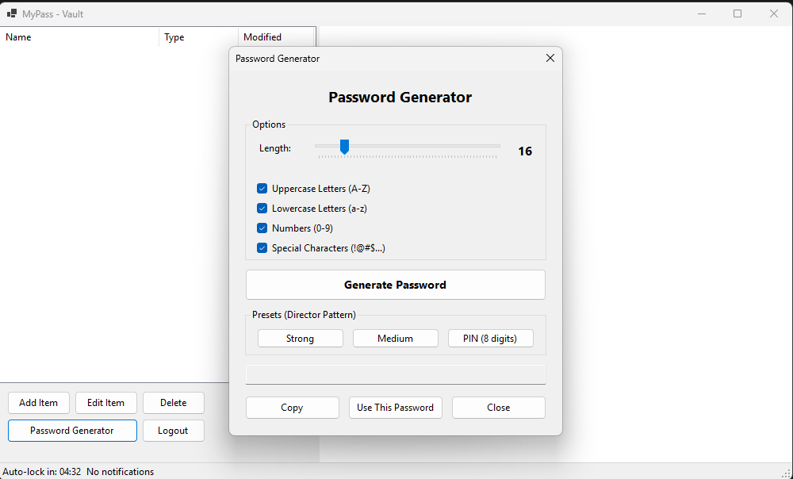
Masked/Unmasked Data
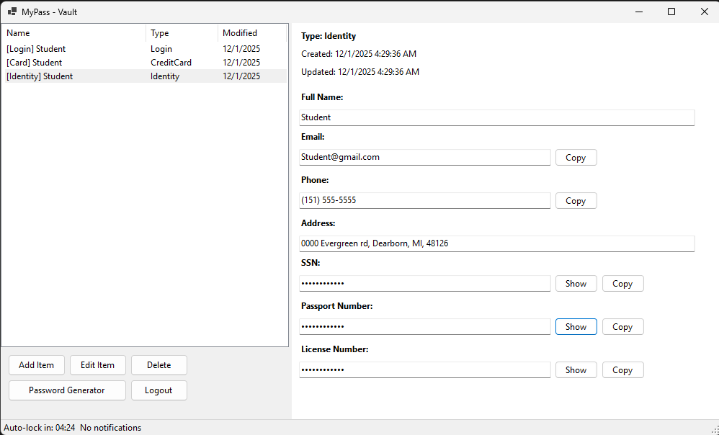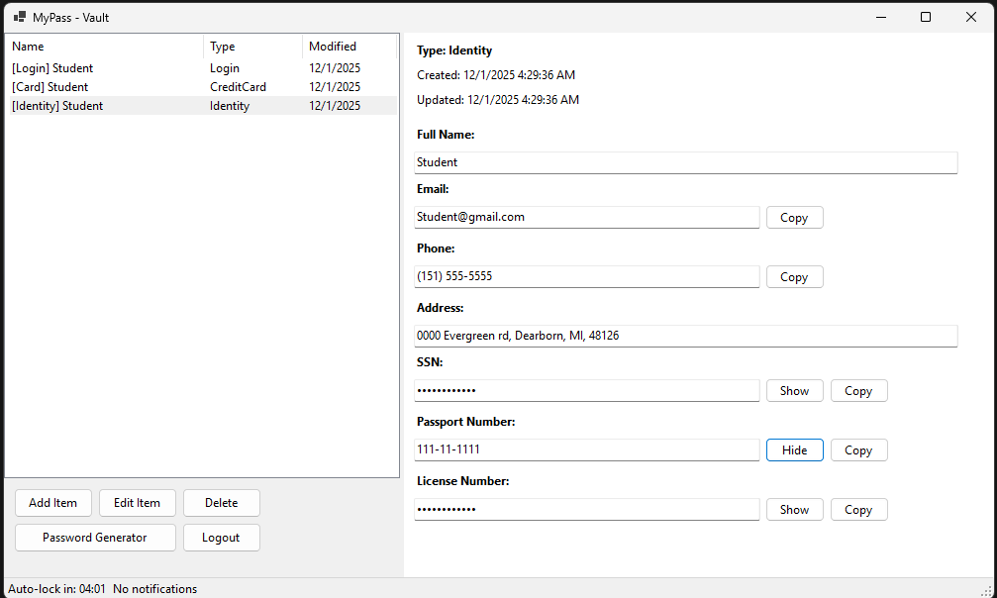
Password Recovery
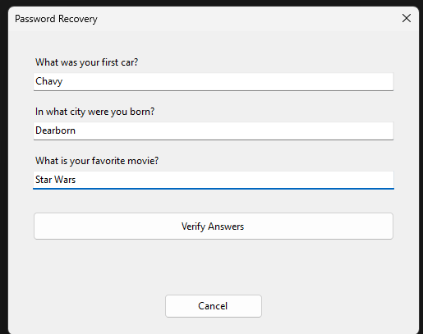

5. Key Features
- User registration with email and master password
- Password strength checker with warnings
- Four vault types: Login, Credit Card, Identity, Secure Note
- Create, read, update, delete vault items
- Password generator with presets
- Auto-lock after 5 minutes of inactivity
- Clipboard auto-clear after 2 minutes
- Data masking for sensitive fields
- Password recovery with security questions
- Notifications for expirations and weak passwords
6. Testing
All six design patterns are tested and working:
- Singleton: Single session instance
- Observer: Notifications trigger correctly
- Mediator: Forms communicate through mediator
- Builder: Password generation works
- Proxy: Data masked/unmasked properly
- Chain: Password recovery requires all three questions
All features tested and functional.

7. References
- Gamma, E., et al. (1994). Design Patterns. Addison-Wesley.
- OWASP Password Storage Cheat Sheet
- Microsoft .NET Cryptography Documentation
- Entity Framework Core Documentation
- Bitwarden (reference implementation)

Build Instructions
- Open MyPass.sln in Visual Studio 2022
- Restore NuGet packages
- Build (Ctrl+Shift+B)
- Run (F5)
Database creates automatically on first run.

